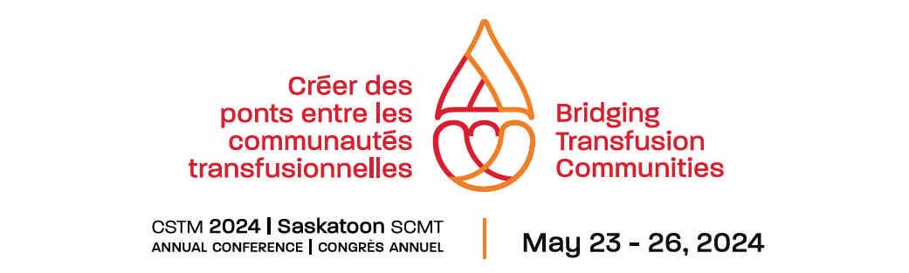

*Call Out for Volunteers!*

Are you looking for ways to connect and become more involved in the transfusion community? The Canadian Society for Transfusion Medicine (CSTM) is a multidisciplinary society which promotes and supports best practice in transfusion medicine in Canada through education, communication and partnerships.

The 2024 CSTM Annual Conference will be held at the TCU Place Convention Centre in Saskatoon on May 23 - May 26, 2024 and there are several volunteer opportunities available. We can use volunteers for short as a couple of minutes to introduce speakers to as long as a few hours to help with registration and conference bag stuffing.

Perks of signing up – volunteers working a 3 hour shift receive a complimentary workshop or conference registration for that day! If you are interested in participating or have any questions, please email Heather Panchuk at [heather.panchuk@saskhealthauthority](mailto:heather.panchuk@saskhealthauthority).ca.